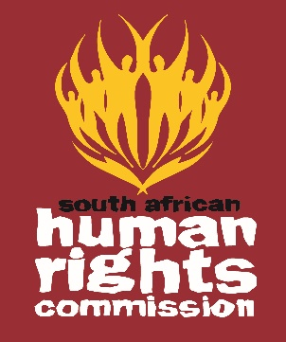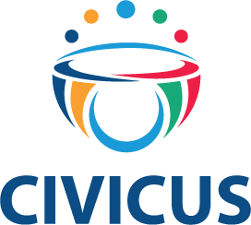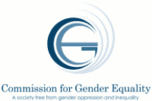

AFRICAN DAY OF HUMAN RIGHTS
PROGRAMME
Date: 20, October 2017
Hosted by the South African Human Rights Commission

09:15-09:30 Arrival & Registration
09:30- 09:45 Opening, Introduction And Objectives
09:45-10:15 Opening Remarks :
- Commission for Gender Equality,
- South African Human Rights Commission,
- Human Rights Institute of South Africa,
- CIVICUS
10:15-10:45 Keynote Address
- Honourable Pansy Tlakula - Chairperson of African Commission on Human and People’s Rights
10:45-11:00 Q&A
11:00-11:30 Freedom of Association, Assembly & Expression
- Teldah Mawarire: CIVICUS
- Zimkhitha Mvandaba: Huffington Post
- SAHRC
11:30-11:45 Q&A
11:45 – 12:00 Tea/ Coffee Break
12:00-12:45 Protection of vulnerable groups
- Sarah Motha Foundation for Human Rights,
- Lindiwe Khoza South Africa Women’s in Dialogue,
- Mawethu Nkolomba Human Rights Institute of South Africa,
- Brian Muziringa Disabled Migrant Rights Networking Organisation,
- Pulane Mafatshe Black Womxn Caucus;
- Lieketseng Mohlakoana-Motopi CGE
12: 45-13:00 Q&A
13:00-13:15 Summary & Closure

